ТЕХНОЛОГИЯ ДИАГРАММИРОВАНИЯ ПРЕДЛОЖЕНИЙ
(Материалы из опыта работы учителя
МБОУ г. Мурманска ММЛ Копалевой Л.А.)

Sentence diagramming
A sentence diagram is a way to graphically represent the structure of a sentence, showing how words in a sentence function and relate to each other. A method of diagramming sentences using word balloons was introduced by S.W. Clark in «A Practical Grammar». Diagramming sentences can help you to:
- Learn and identify the parts of speech
- Understand how the parts of speech function together to create compound sentences
- Explore methods of joining subjects, verbs and objects
- Understand complex grammatical tools used to make compound sentences, including prepositional phrases, verbal nouns, modifiers and compound subjects.
The diagram of a simple sentence begins with a horizontal line called the base. The subject is written on the left, the predicate on the right, separated by a vertical bar which extends through the base. The predicate must contain a verb, and the verb either requires other sentence elements to complete the predicate, permits them to do so, or precludes them from doing so. The verb and its object, when present, are separated by a line that ends at the baseline. If the object is a direct object, the line is vertical. If the object is a predicate noun or adjective, the line looks like a backslash, \, sloping toward the subject.
Simple sentences are diagrammed in accordance with the following basic schemata:

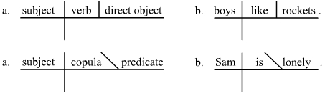
Practice

Boys speak loudly
- Draw a long horizontal line with a vertical slash.

- Find the verb in the sentence. Write it after the slash.
3. Find the subject (the person/thing “doing” the verb) and write it before the slash.
speaks
Boys
speak
- Place modifiers on right diagonal lines below the words they modify. Adjectives modify nouns and adverbs modify verbs.

Modifiers of the subject, predicate, or object dangle below the base line:

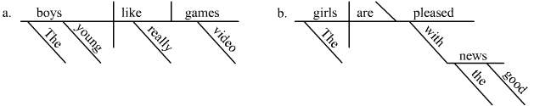
Modifiers, including Adjectives (including articles) and adverbs are placed on slanted lines below the word they modify. Prepositional phrases are also placed beneath the word they modify; the preposition goes on a slanted line and the slanted line leads to a horizontal line on which the object of the preposition is placed.

- A direct object is a noun that receives the action of the verb.

Keanu delivered the package. What was delivered? the package.
Jason committed a crime. What was committed? a crime.
Matthew always serves good cake. What was served? Cake.
Direct objects are written after a slash (above the line) after the verb.
Keanu
delivered
package

- Indirect objects are diagrammed under the verb like this
Keisha
built
house
her

- Try these sentences.
  - The old man walks quickly.
B. My little fish swims silently.
- His older brother dances well.
- The hefty cow is grazing quietly.
- My sweet English teacher can write well.
- Jordan should have been talking softly.

These basic diagramming conventions are augmented for other types of sentence structures, e.g. for coordination and subordinate clauses.

A compound sentence
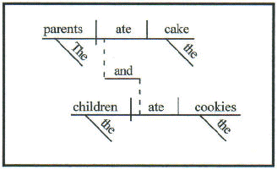
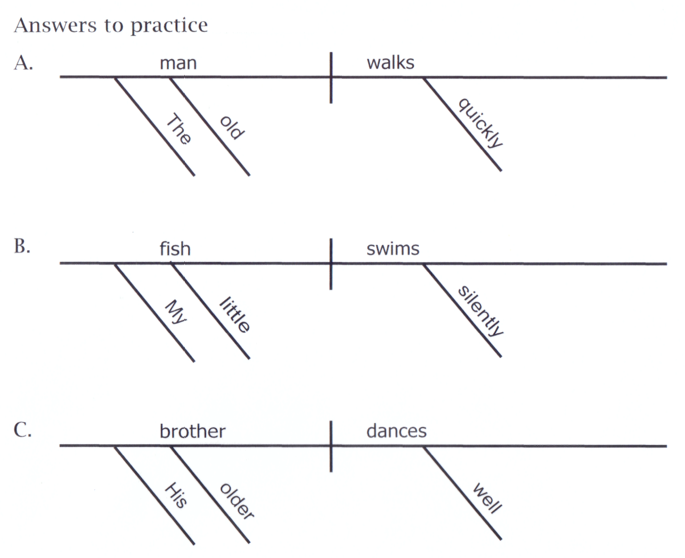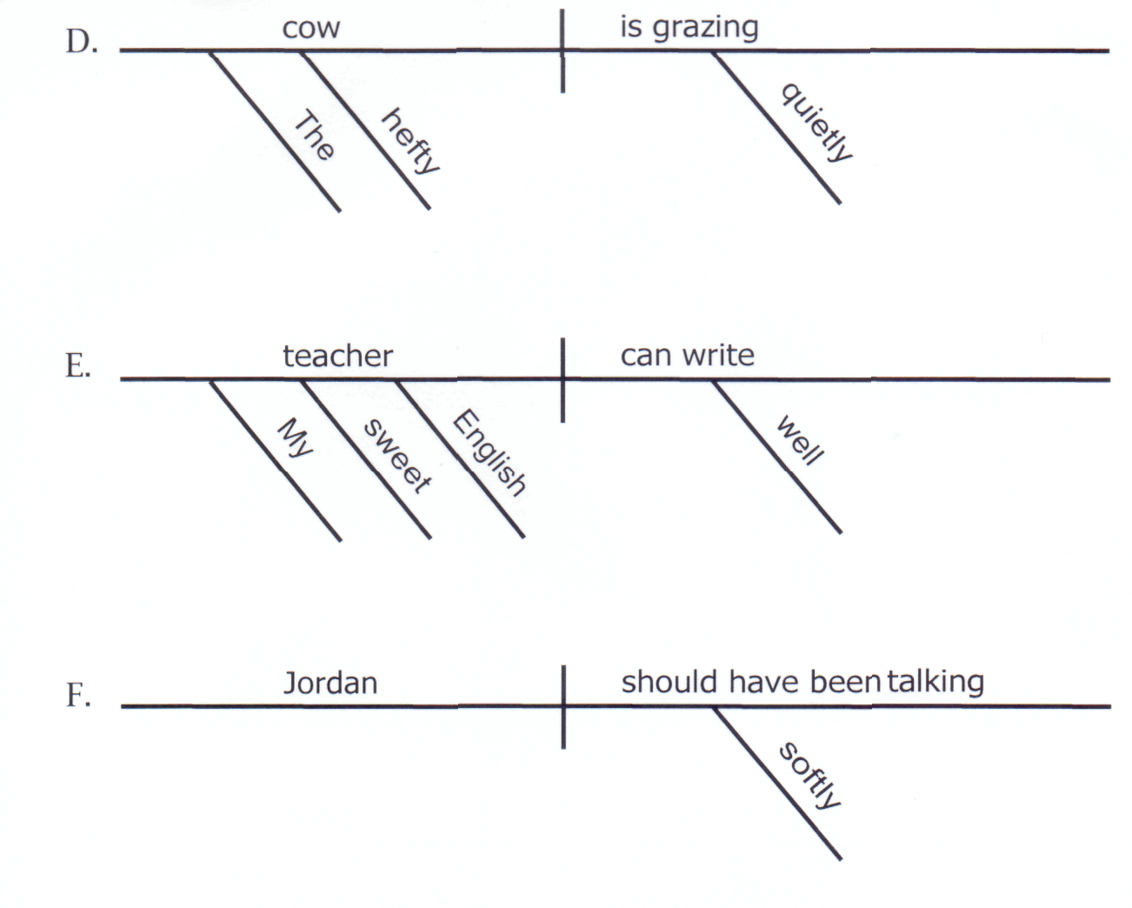

ПРИЛОЖЕНИЯ

План-конспект урока английского языка (фрагмент)
в 5 классе по теме «Fluffy friends at school»
с использованием заданий предельного типа
(нооген типа «система + элемент»)
Пашковская Л.А.,
учитель МБОУ г. Мурманска гимназии № 6

Практическая цель: развитие навыков говорения по теме.
Задачи:
Образовательные:
- развитие навыков говорения, лексических и грамматических навыков по теме «Животные» и «Школа».
Воспитательные:
- развитие умения общаться с одноклассниками и учителем в рамках темы;
- прививать уважительное отношение к другим странам и культурам.
Развивающие:
- развитие внимания;
- развитие памяти;
- развитие эмоциональной сферы;
- развитие кругозора;
- развитие способностей к логическому изложению, к формированию выводов.
Оснащение: раздаточный материал – карточки, билеты, проектор, ноутбук, экран.
Приложение к конспекту: мультимедийная презентация.
Ход урока
- Организационный момент. Good morning! Glad to see you. How are you boys and girls? Take your seats, please, and get ready for the lesson. Well, I want to greet our guests.
If you are ready for the lesson, let’s start.
- Речевая зарядка. Сообщение целей и задач урока. So, we continue speaking about very nice creatures in our life – animals, and today we will speak about pets. Student 1, read the topic, please. (слайд 1)
Student 1: “Fluffy friends at school. Isn’t it cool?”
- Активизация лексических единиц по теме «Школа» и «Животные».
So, today we’ll speak about school and pets! Let’s first remember what pets can you name? (на слайде 2 – изображения домашних животных).
Students: “a dog, a cat, a hamster, a guinea pig, a parrot”.
Have you got a pet? What pet have you got? Is it big/funny/fluffy/nice?

- Развитие навыков устной речи. Работа в группах.
Good. And now let’s see what school objects you remember. (На слайде 3 – изображения школьных принадлежностей.)
Students: “A book, a ruler, a pen, a pencil, a blackboard, a desk, an eraser, a copybook etc”.
Very good! I see that you know a lot about pets and your school, and you love pets and school very much! Now, look at the board and think – “Can pets and school be together?” (слайд 4)
What if you have new classmate like these (слайд 5-6), a music teacher (слайд 7), a class mistress (слайд 8), a P.E. teacher (слайд 9), a geography teacher (слайд 10), or an English teacher (слайд 11) like this?
So, your task is to imagine pets at school and answer the questions (слайд 12) Work in three groups. You have a sheet of paper and dictionaries on the desk to help you. Write down your ideas and get ready to give a short talk.

…pets are at school every day…
1) What can we do with pets?
2) What can pets do at school?
3) How can they be useful?
4) Who can like this idea and why?
5) Who can dislike this idea and why?
6) What do YOU think?

Работа в группах.

Well, boys and girls, time is up! Let’s start! Group number one comes to the blackboard and tells us their answers!

So, now we see that pets at school can be very fun, but also a bit noisy!

Завершение фрагмента урока. На дальнейшем этапе работы предполагается подготовка к написанию сочинения по данной теме.

Примечание.
В процессе работы у ребят возникают лексические трудности, решить которые помогает работа со словарем и слаженная работа участников группы. Использование словаря при работе с задачами предельного типа необходимо на всех этапах обучения.
План-конспект урока английского языка (фрагмент)
по теме «An unusual job»
Редько Н.Э.,
учитель МБОУ г. Мурманска гимназии № 6
Оснащение урока: наглядный материал (презентация Power Point), трейлер к мультипликационному фильму «Зверополис» на английском языке.
Раздаточный материал: карточки с грамматическим и лексическим материалом.
Оборудование: компьютер, проектор, экран, колонки.
Ход урока
1. Организационный момент
Teacher: Dear students, I’m glad to see you. Take your sits. Today we have only a half of a lesson, 25 minutes. We will have a very interesting topic. Be active and don’t be shy. Let’s start our lesson!
Teacher: I want to show your one video. Look at the screen.
(Показ трейлера) Do you recognize it?
Pupils: Yes. It is “Zootopia”
Teacher: Have you watched it before? Do you like it?
Pupils: Yes! It is a very funny cartoon.
Teacher: Today we have our own Zootopia. We will speak about unusual professions for animals. Slide 1
2. Постановка проблемы
Slide 2-7. На каждом слайде сначала появляется изображение человека, принадлежащего определенной профессии.
Teacher: What is he?
Pupils: He is a firefighter.
What qualities should he have to be good at his job?
Pupils: He should be strong and brave.
Затем на экране появляется изображение слона.
Teacher: What if we mix them? Is it good for this job?
Картинка слона-пожарного.
Pupils: Предлагают свои варианты.
Slide 8.
Teacher: Do you agree that these jobs are unusual for animals?
How can we describe them? What can we tell about them?
We will work in groups. Each group will present only one animal. You have a plan on your shееts of paper. For each point your team will get a medal. After your presentation, other teams can add ideas and get medals too. In the end we will count your medals and choose the winner.
3. Групповая работа
В группах идет обсуждение животного с необычной профессией по следующему плану:

Plan
- It can____________________
- It is good at this job because it________________________
- It’s difficult for it because it_________________________

Так же ученикам представляется небольшой список возможных отрицательных и положительных качеств, которые они могут применить в своем рассказе (an elephant-firefighter):
- use its trunk to spray water
- is strong
- lift heavy things
- can’t drive a car
- can damage walls
- can’t climb trees and ladders
4. Представление результатов групповой работы
Teacher: Let’s listen to the first team.
Pupils: (возможный вариант)
We think that an elephant can be a good firefighter. It can use its trunk to spray water. Also it is calm and doesn’t panic. On the other hand, it is difficult for him to be a firefighter because it is very heavy and can’t drive a car.
Teacher: Well done! Your get 3 medals. Does anybody want to add?
Pupils: It can’t climb ladders!
Teacher: Good! You get one medal.
Далее остальные команды представляют свои рассказы, дополняют друг друга и получают медали за ответы.
5. Подведение итогов
Teacher: Let’s count your medals. The winner is the first team! Our congratulations! Our short lesson is over now. Thanks for your good work! See you!

